
2025/2026
Lab 3: Stack

FAKULTI SAINS KOMPUTER DAN MATEMATIK
DATA STRUCTURE & ALGORITHM

VERSION 1
Name: ARISYA SYAHIRAH BINTI AZIZI
Matric Number: S76119
Lab: MP1
Date: 3/11/2025
Table of Contents
INSTRUCTIONS 1
TASK 1: Apply and test the simple implementation of stack 2
TASK 2: Decimal to Binary Converter 6
TASK 3: Binary To Decimal Converter……………………………………………………………..…………….8

INSTRUCTIONS

Manual makmal ini adalah untuk kegunaan pelajar-pelajar Fakulti Teknologi Kejuruteraan Kelautan dan Informatik, Universiti Malaysia Terengganu (UMT) sahaja. Tidak dibenarkan mencetak dan mengedar manual ini tanpa kebenaran rasmi daripada penulis.
Sila ikuti langkah demi langkah sebagaimana yang dinyatakan di dalam manual.

This laboratory manual is for use by the students of the Faculty of Ocean Engineering Technology and Informatics, Universiti Malaysia Terengganu (UMT) only. It is not permissible to print and distribute this manual without the official authorisation of the author.
Please follow step by step as described in the manual.

TASK 1: Apply and test the simple implementation of stack

Objective
In this task, students must be able to:
- Apply the simple implementation of stack.
- Test the implementation

Estimated Time
[60 Minutes]

steps:
- Open Netbeans and create new java application project.
- Named your project as StackExperiment and click finish.
- Change author profiles to :
  - Name :
  - Program: <put your program. Eg: SMSK(SE) or SMSK with IM
  - Course : CSF3104
  - Lab : <enter lab number>
  - Date : <enter lab date> [Step 2]
- Add the following class to your StackExperiment.java file after author profiles and before public class StackExperiment statement. [Step 3]

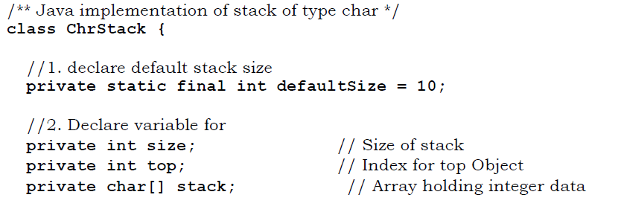

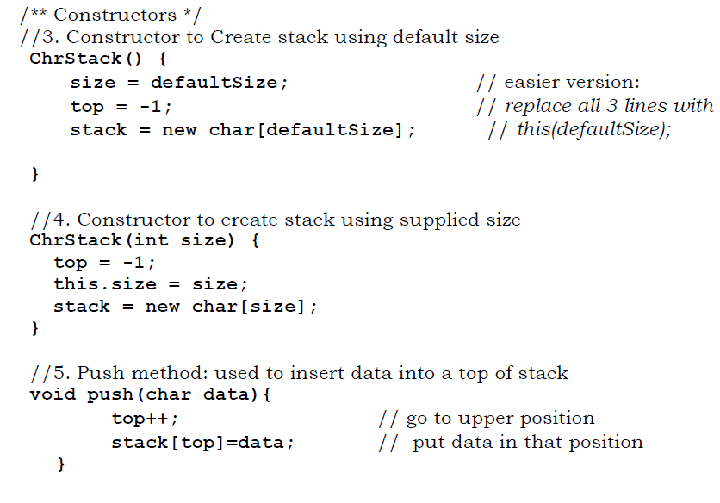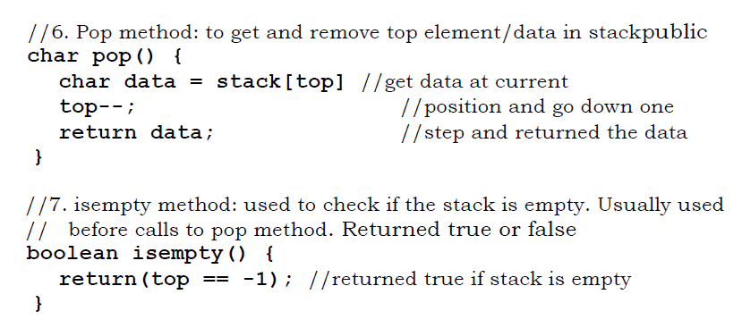

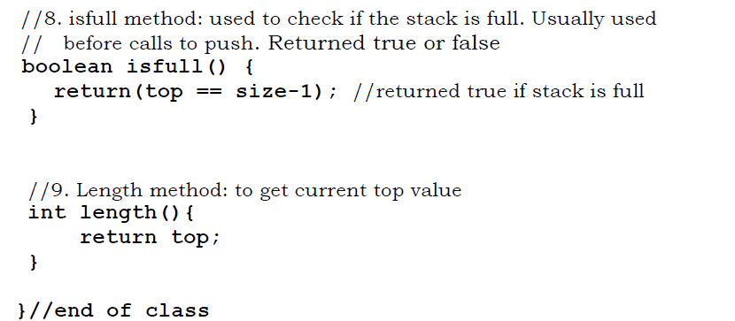

- Put the following code in your main method.
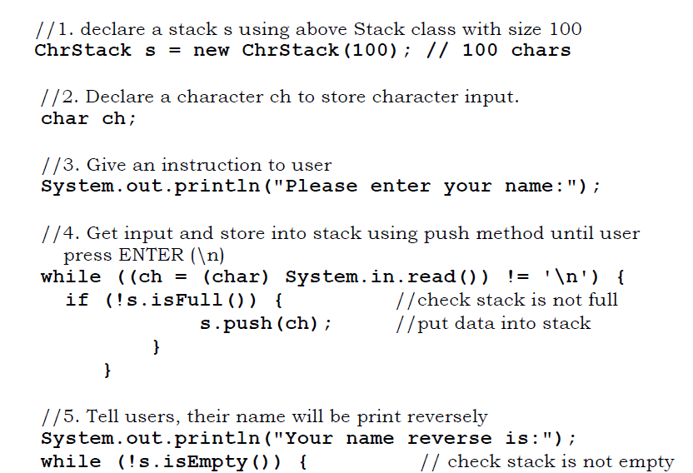

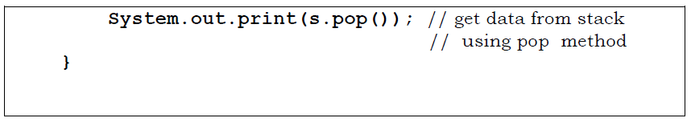

questions
- What did the program do?
Answer: it will ask you to enter your name and the output will be your name but spelled in reverse
- If your input is “Fakulti Teknologi Kejuruteraan Kelautan Dan Informatik”, what is inside stack s during you enter for word “Teknologi”?
Answer: 9
- Try put the following input and see what happen. Explain why it happened.

Do not get worried and do not get scared, we are fighting to get there. So remember, out there somewhere you have got a friend and you will never walk alone again
Answer: the whole sentence is spelled backwards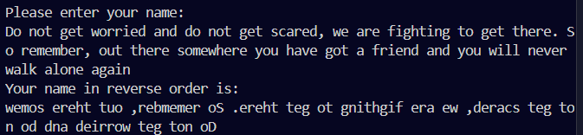
- If the stack is intended to store the integer data, what should be change in a ChrStack above (will be use later in Task2)?
Answer: to change all the char data types into integer

TASK 2: Decimal to Binary Converter

objective
In this task, students must be able to use stack to store data for converting decimal number to binary number.

estimated time
[60 Minutes]

steps:
- Create a new project on java applications in netbeans.
- Named the projects as Dec2Bin
- Beside the default java class that have main method, add new file of java class to your project and named the file as IntStack.
- Copy the contents of ChrStack in Task 1 into IntStack file and change accordingly so it can support integer data.
- Go to main method of Decimal2Binary.java file and do the following
  - Declare a new stack s with size 25 using IntStack class.
  - Declare a variable decNumber of type integer.
  - Instantiate input function based on Scanner class. Named the object as scanInput. (You need to import Scanner class before doing this).
  - Get an integer input and store in a decNumber.
  - Define a boolean variable called stop with default value false.
  - Repeat the following code until stop is set to true.
    - Push the reminder of decNumber divided by 2 into stack
if (!s.isFull()
s.push(decNumber % 2)
    - Get the quotient of division and store back into decNumber
decNumber = decNumber / 2
    - Check if we can stop the loop. The loop must be stop when current value of decNumber is either 0 or 1. The loop is stopped when variable stop is true. Before stop, push the final value of decNumber into stack s

if (decNumber == 0 || decNumber == 1){
if (!s.isFull()
s.push(decNumber);
stop = true;} }
- The stack s now contains the binary value of decimal number. Now is time to pop it out one-by-one onto screen.
- Repeat the following code until the stack is empty.
while(!s.isEmpty()){
System.out.print(s.pop()+" ");
}

questions
- In Step 5d, user may enter non-integer input, to handle that situation you may use try-catch block. Show how try-catch block can be implemented in above program
Answer: It will show and error message saying “Input cannot be a non-integer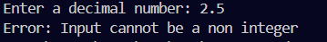

TASK 3: Binary to Decimal Converter estimated time [60 Minutes] steps: Using a similar step in Task 2, write a java program to convert binary number to decimal number. The given algorithm may help you to get the idea. 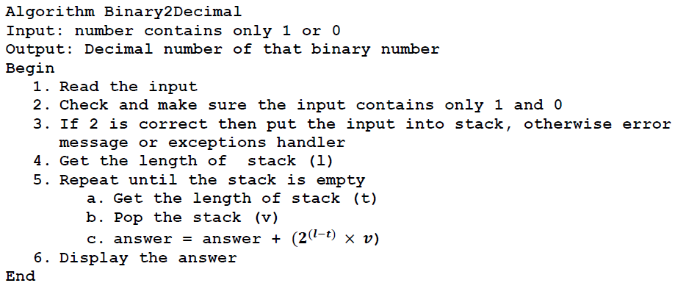 Example of output: INSTRUCTION: Please submit this lab module and zip all the codes (only java files) to epembelajaran. Binary num in Source Code Activity 3 Bin2Dec.java public class Bin2Dec { //stack size private static final int defaultSize =10; //variable private int size;//sizeof stack private int top;//index in top private int [] stack;//array holding int data //constructors Bin2Dec(){ size = defaultSize; top = -1; stack = new int[defaultSize]; } //to create stack using supplied size Bin2Dec(int size){ top = -1; this.size = size; stack = new int[size]; } //push method to insert data to the top stack void push(int data){ top++;//GO TO upper position stack[top] = data;//put data in the position } //pop, to remove top element/data in the public stack int pop(){ int data = stack[top];// get data at the current top--;//position and to go down one step return data; //step and return data } //isEmpty used to check if the stack is empty, //usually before pop to check boolean isempty(){ return(top == -1);//if top is -1, stack is empty } //8.isfull, used to check if the stack is full //before it calls push,t or f boolean isfull(){ return(top == size - 1); } // 9. lenght method, to get current top value int length(){ return top; } } Binary2Decimal.java import java.util.Scanner; public class Binary2Decimal { public static void main(String[]args) { try{ //s size= 25 Bin2Dec s = new Bin2Dec(25); // int binary = 0; // int id =0; Scanner input = new Scanner(System.in); System.out.print("Enter a binary number: "); String binaryStr = input.next(); //validate binary input if (!binaryStr.matches("[01]+")) { System.out.println("Error: Input must contain only 0s and 1s"); return; } // Convert binary string to decimal using stack int decimalValue = 0; int power = 0; for(int i = binaryStr.length() - 1; i >= 0; i--){ char digit = binaryStr.charAt(i); if(!s.isfull()){ s.push(Character.getNumericValue(digit)); } } //calculate decimal value by popping stcak while (!s.isempty()){ int digit = s.pop(); decimalValue = decimalValue * 2 + digit; } //now stack s contains binary value of decimal number System.out.print("Decimal value is: " + decimalValue); }catch(Exception e){ System.out.println("Error: Invalid input - " ); } } } Output 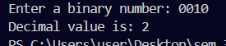 If other int except 1 & 0 is enterd 